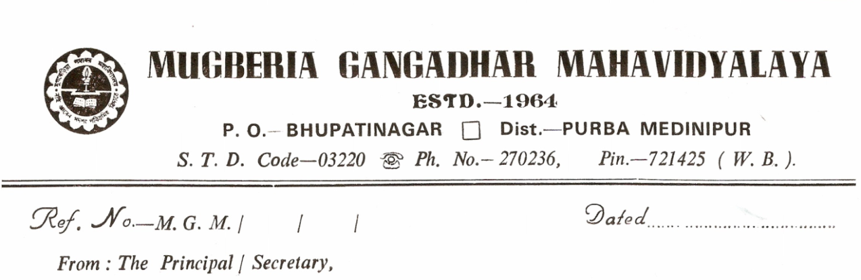
NOTICE
This to notify for all concerned that on account of the Birthday of Pandit Ishwar Chandra Vidyasagar the college will remain close on 26th September, 2022 Monday . The college will reopen 27th September Tuesday as usual.

Dr. Swapan Kumar Misra
Principal
Mugberia Gangadhar Mahavidyalaya

