MUGBERIA GANGADHAR MAHAVIDYALAYA
Bhupatinagar, Purba Medinipur

Specific facilities provided for Female students to promote a Gender-positive environment:
a. Safety and Security
● Security checkpoints at the campus entry and exit.
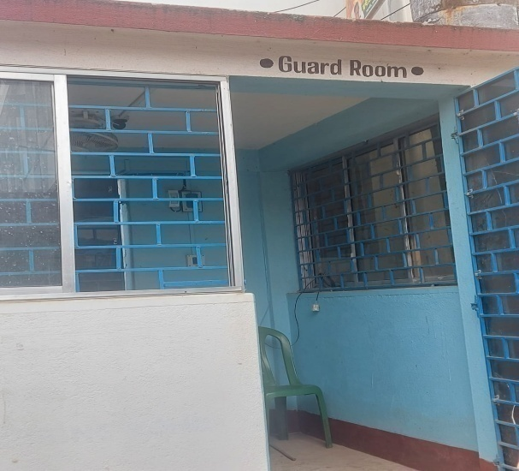
Security Room at the College Entrance

● Extensive surveillance network with 24x7 CCTV.
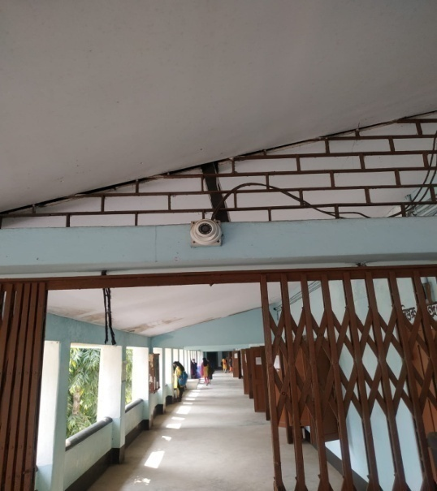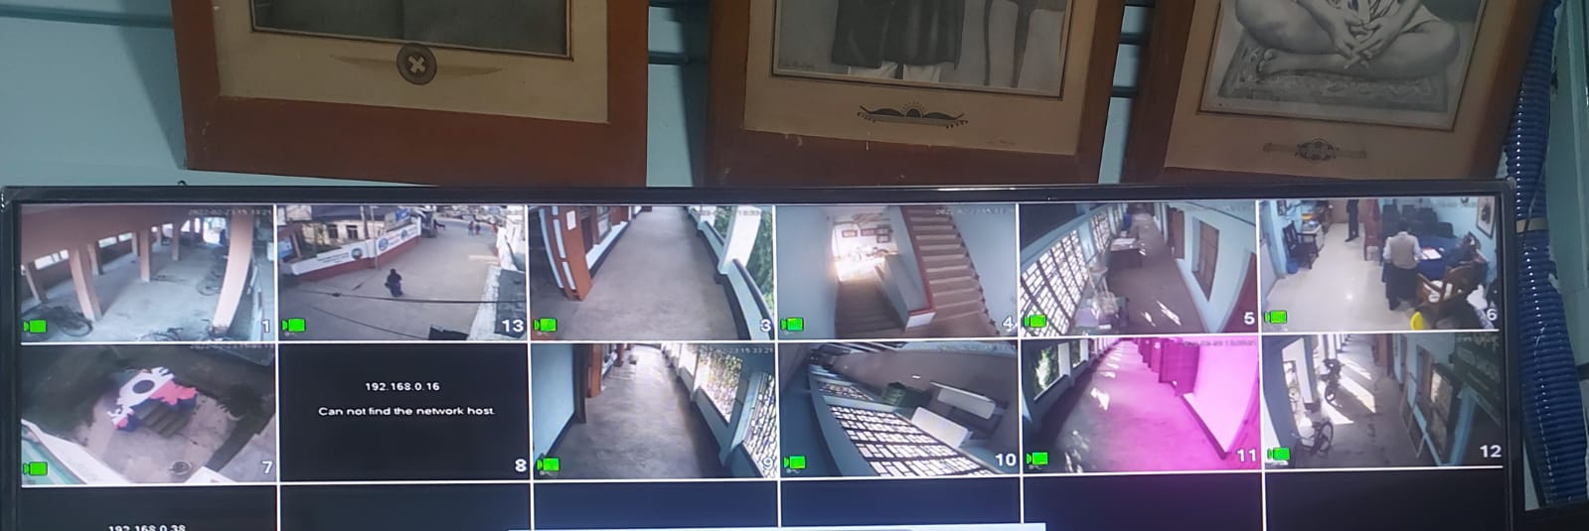
● To ascertain proper gender sensitization, the college has a Gender Sensitization Committee Against Sexual Harassment (GSCASH) established in the year 2014, after the Vishakha cell legislation was passed in 2013.
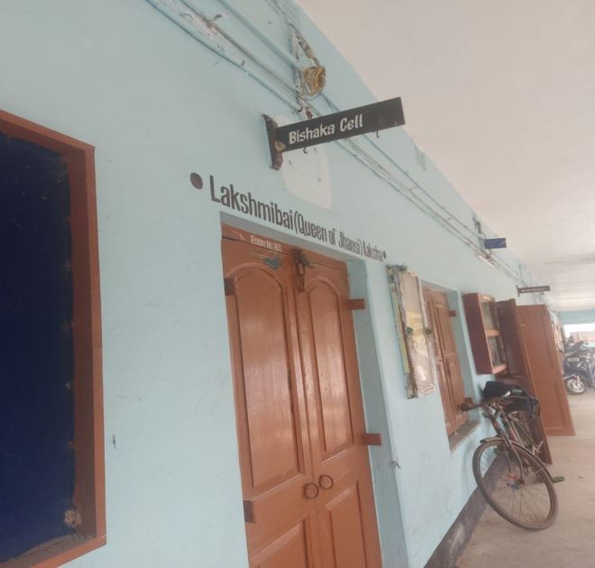
● The college has a Women Cell that looks after the security issues of female students very seriously. (Contact- Prof. Jonaki Biswas, Head and Associate Professor,Department of Political Science)
● The institution has posters with displayed phone numbers that encouraging students to contact the authority incase of slight discomfort regarding his/ her safety and security inside and outside the campus.

● Several awareness campaigns on women safety and gender sensitivity are taken up by the colleges that ensure gender equity and consciousness.

●The college boasts of modern bathrooms for both male and female students. Proper care is taken to maintaine hygiene and cleanliness with the help of dedicated staff.
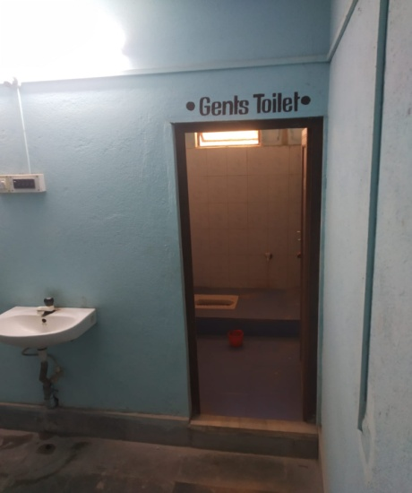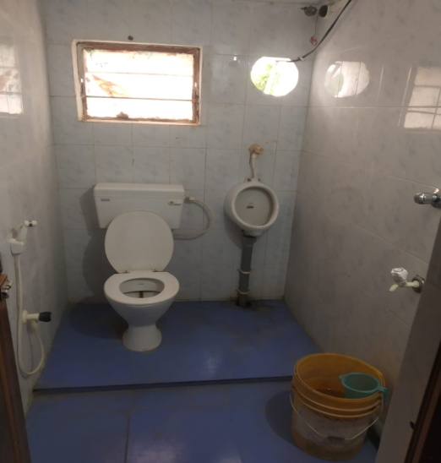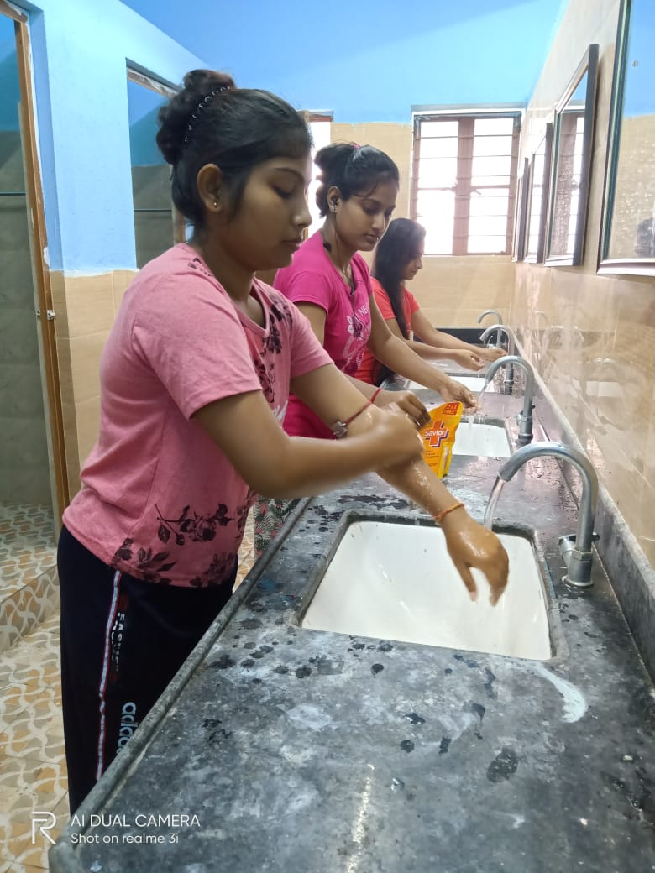

●A Sanitary Napkin Vending machine has been installed in the Girls’ Common Room to aid menstrual hygiene awareness and combat superstitions and taboo regarding the same.
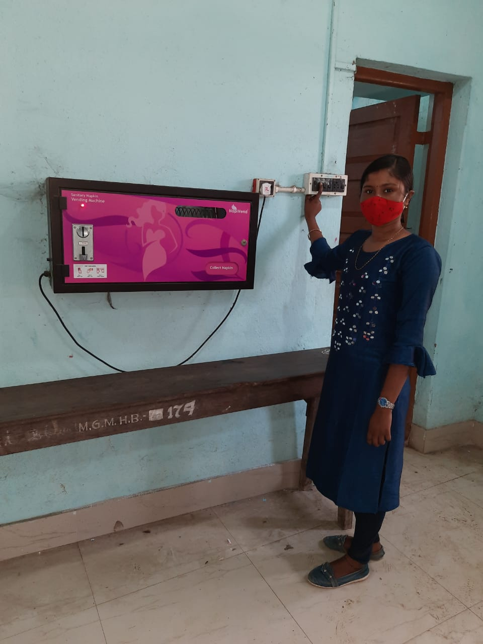
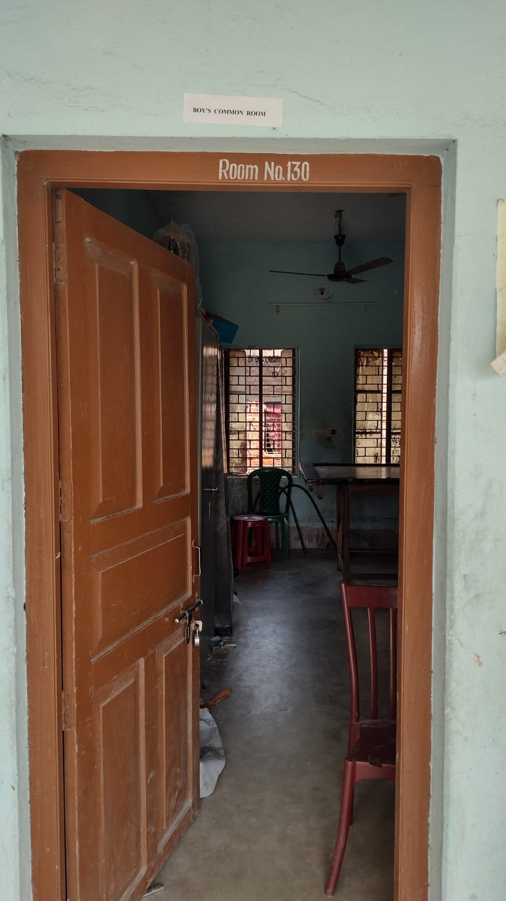
Boys’ Common Room
● Separate hostels for male and female students with equal facilities and dedicated wardens. (Intake capacity: Girls’ Hostel-134; Boys’ Hostel- 100 )
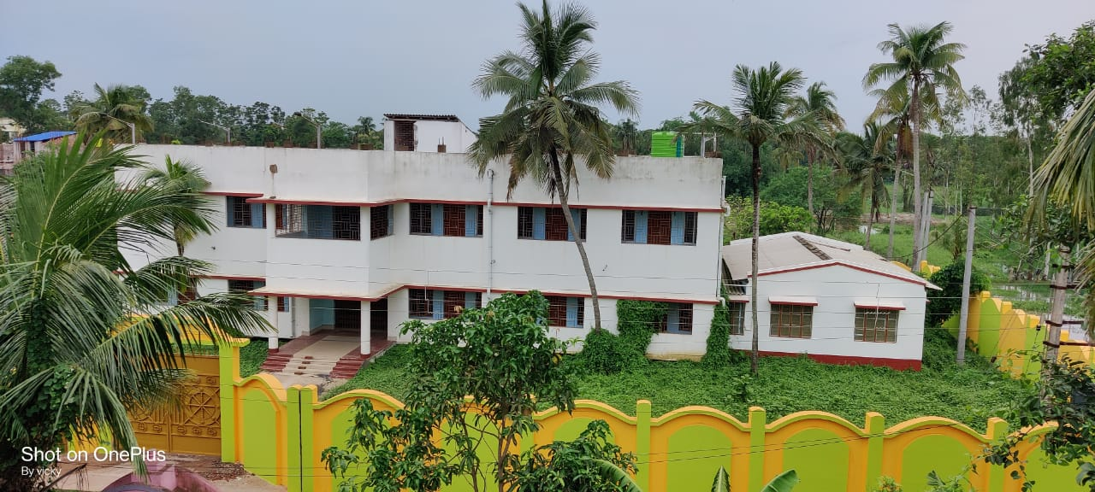
Girls’ Hostel (Shailaja Nanda College Hostel) of Mugberia Gangadhar Mahavidyalaya
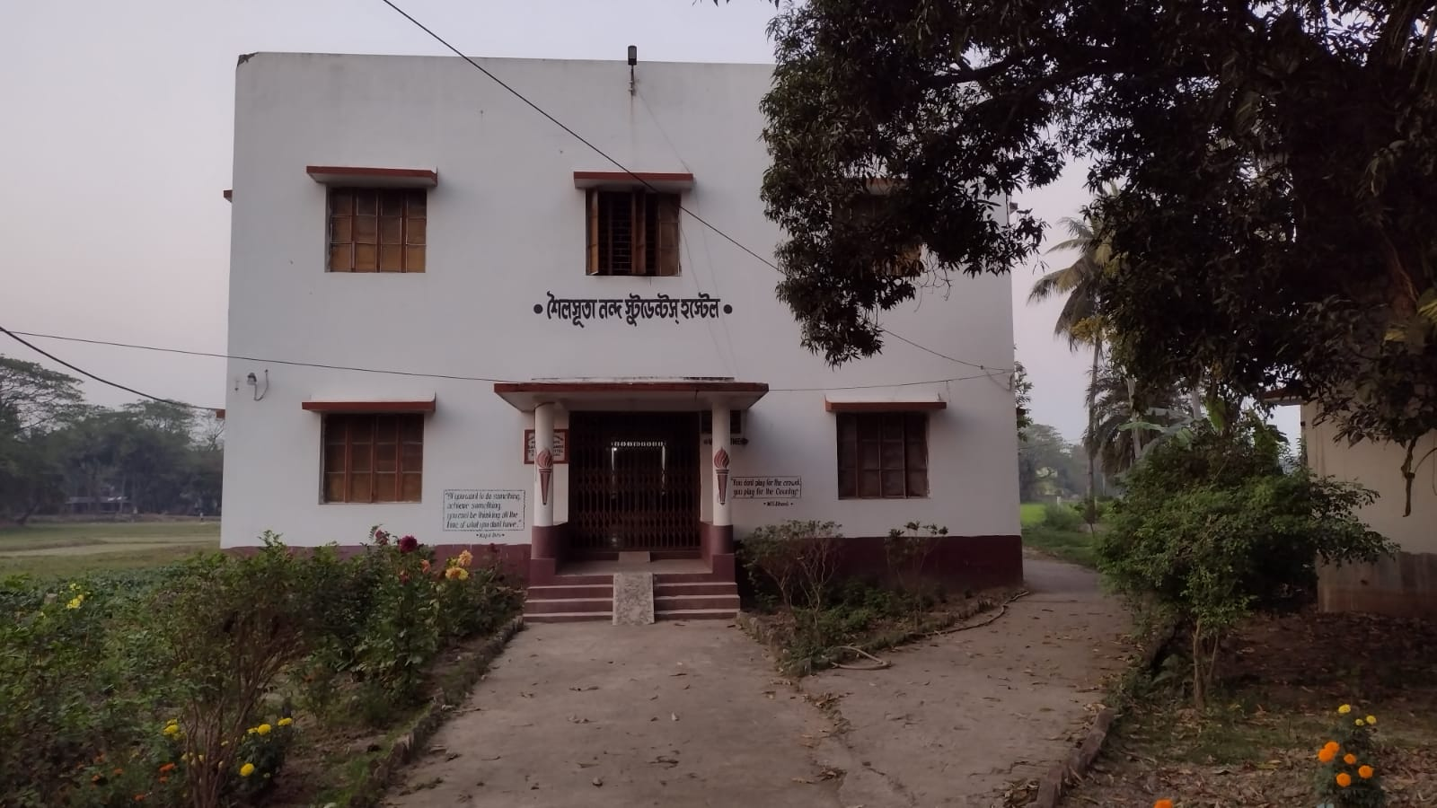
Girls’ Hostel (Shailsuta Nanda College Hostel) of Mugberia Gangadhar Mahavidyalaya

● Also, set up in a rural background with limited transport facilities, the college reduces its teaching hours during winter time to ensure that the students safely return home.
● The college has dedicated female attendant who has been assign to look after the safety and security of the female students.
a. Counseling
Mugberia Gangadhar Mahavidyalaya has taken various measures for counseling students and staffs to ensure personality augmentation that, in turn will ascertain a free and confident environment inside the campus.

● Every department looks after the career counseling of students (both male and female) as and when required.
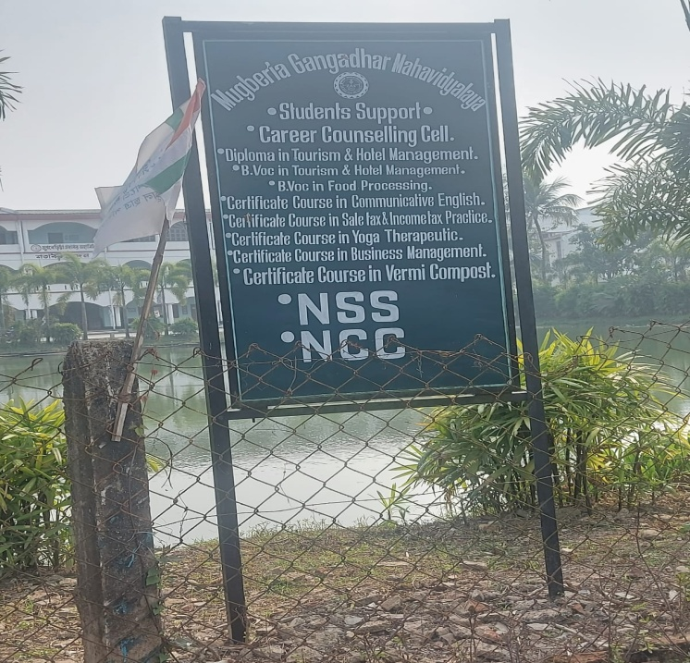
● Dedicated grievance redressal committee is set up in the college that looks after counseling of both male and female students and staffs.
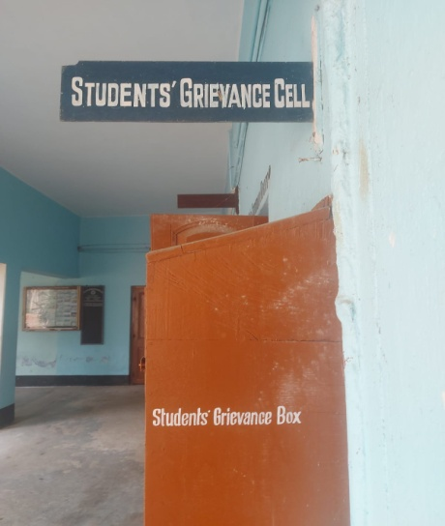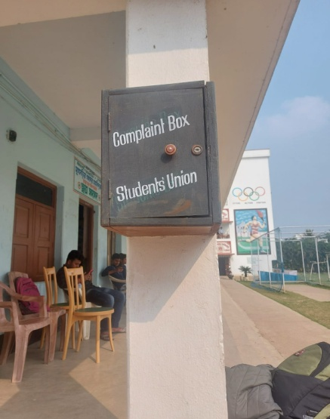
● Some of the departments ensure Entrance Exam Counseling with efficient and skilled teaching staffs.
● Every department takes up induction program at the beginning of new session that ensures mental orientation of the students.
● Every department in the college has its own wall magazine publication by the students that assures students personality development.
● Orientations regarding professional development are regularly conducted for Teachers by the research cell of the college that guarantees not only professional development, but also instills confidence among teachers.
● The college has dedicated Placement Cells that assists in students future counseling and development.
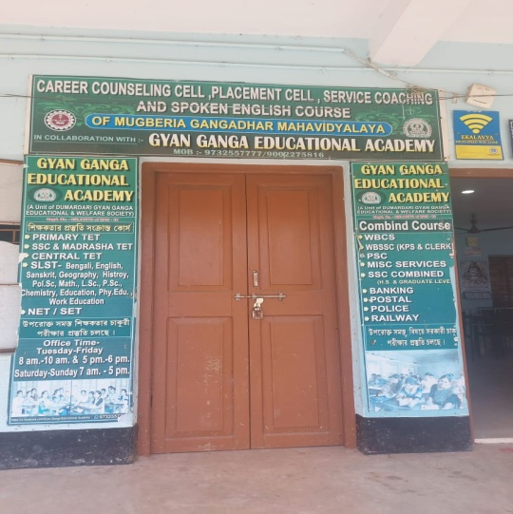
Career Counseling and Placement Cell

● Camps arranged by the B.Ped department and NCC ensures Moral Counseling and value counseling to the students.
● Through community development works taken up by NSS, students are counseled to inculcate cooperation and values among themselves.
b. Common Rooms
Mugberia Gangadhar Mahavidyalaya believes in holistic development of an individual through knowledge and cooperation. For this, the following measures are taken up in the college campus.
● The college has dedicated common room for female students.
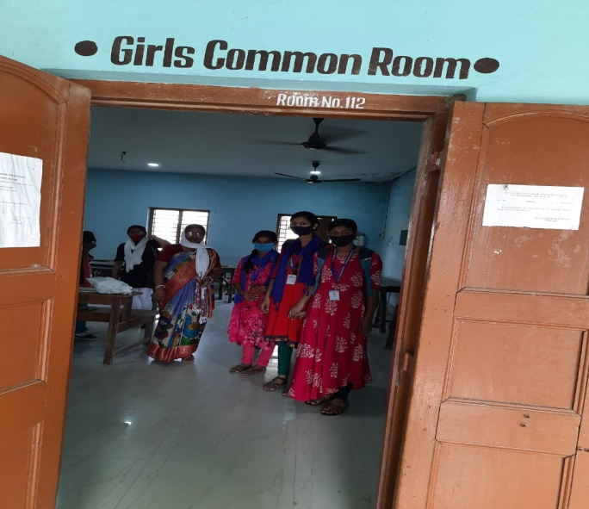

● Beside the master common room, most of the departments have rooms allocated for teachers which also facilitate meetings and discussions.

c. Other Measures
● Several webinars and discussion on gender equity are taken up by the college during the session 2020-21
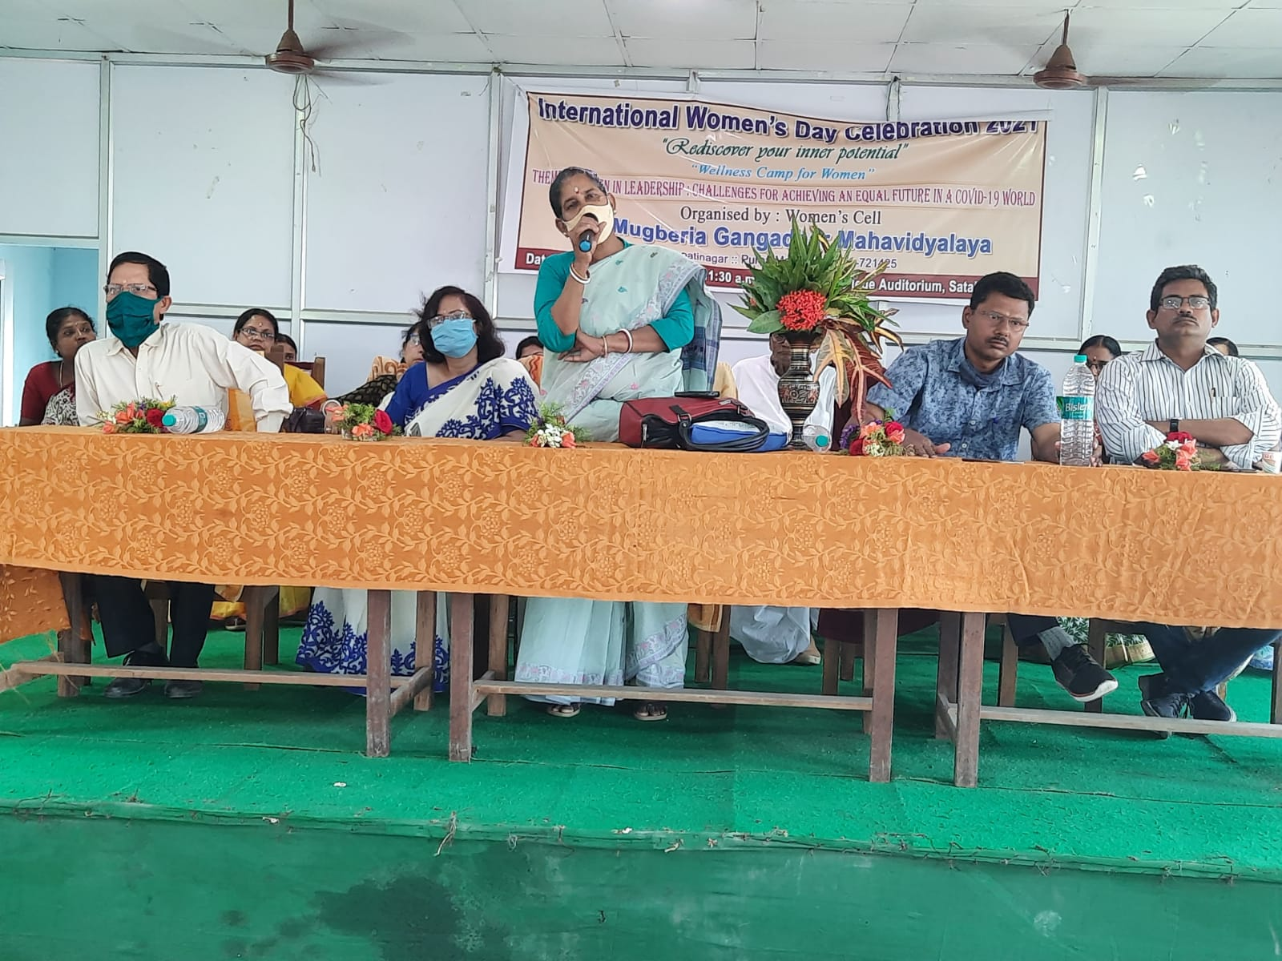
International Women’s Day Seminar held in College on 08.03.2021

● The college seriously encourages in annual sports event in the college to initiate healthy body and disciplined mind for a better future. On 12.07.2020, (after the notice issued by the WBHED about the gradual upliftment of lockdown), the college arranged an inter college football tornament with P.K College, Contai, to boost up students mental and physical health.
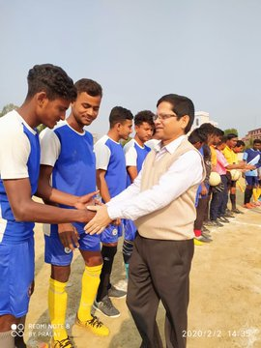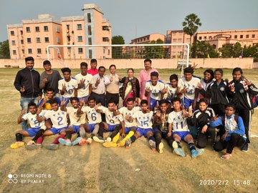
Inter-college football tournament with P.K College, Contai

● The college celebrates world yoga day, and swachchwta phakhwada to ensure prosperity and personality through good health.

Programs organized by the College to uphold commitment towards Gender Equity:

Nb. Due to the pandemic (Covid 19), several other activities that require physical proximity, couldn’t have been possible. The programs that are been taken up were all online.
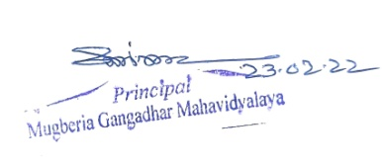

Sl. No. | NAME OF THE PROGRAM | DATE | STUDENTS ATTENDANCE
 |  |  | MALE | FEMALE
 | One day state level webinar on Women and the Pandemic | 29.08.2020 | 100 | 110
 | One day state level seminar on Women in Leadership Challenges for achieving an Equal Future in a Covid 19 World | 08.03.2021 | 200 | 230

